ALT TEXTS.

7. FIGURES
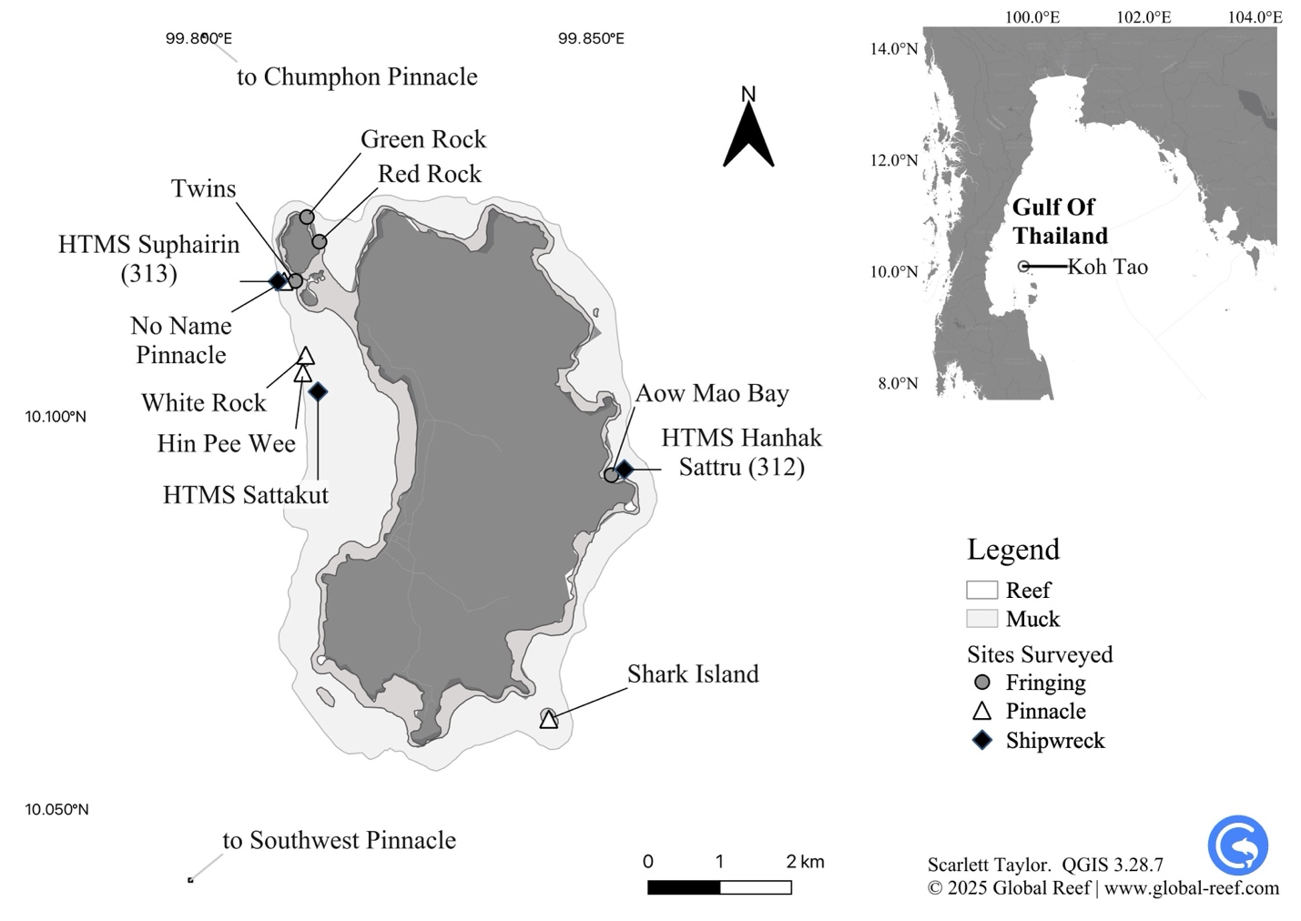
Figure 1 Dive sites surveyed around Koh Tao in the Gulf of Thailand (10.10980°N, 99.81180°E).
ALT TEXT Figure 1: Map showing dive survey sites around Koh Tao, a small island in the Gulf of Thailand. The main map outlines Koh Tao’s coastline in dark grey, with reefs shown in pale grey and muck habitats in white. Circles mark fringing reef sites such as Green Rock, Red Rock, and White Rock along the island’s coast. Triangles indicate pinnacle sites, including Southwest Pinnacle, No Name Pinnacle and Shark Island, further offshore than the fringing reefs. Diamonds show shipwrecks, including HTMS Suphairin, HTMS Sattakut, and HTMS Hanhak-Sattru. A smaller inset map in the upper right locates Koh Tao within the Gulf of Thailand. A north arrow, scale bar, and labeled coordinates are included for orientation.
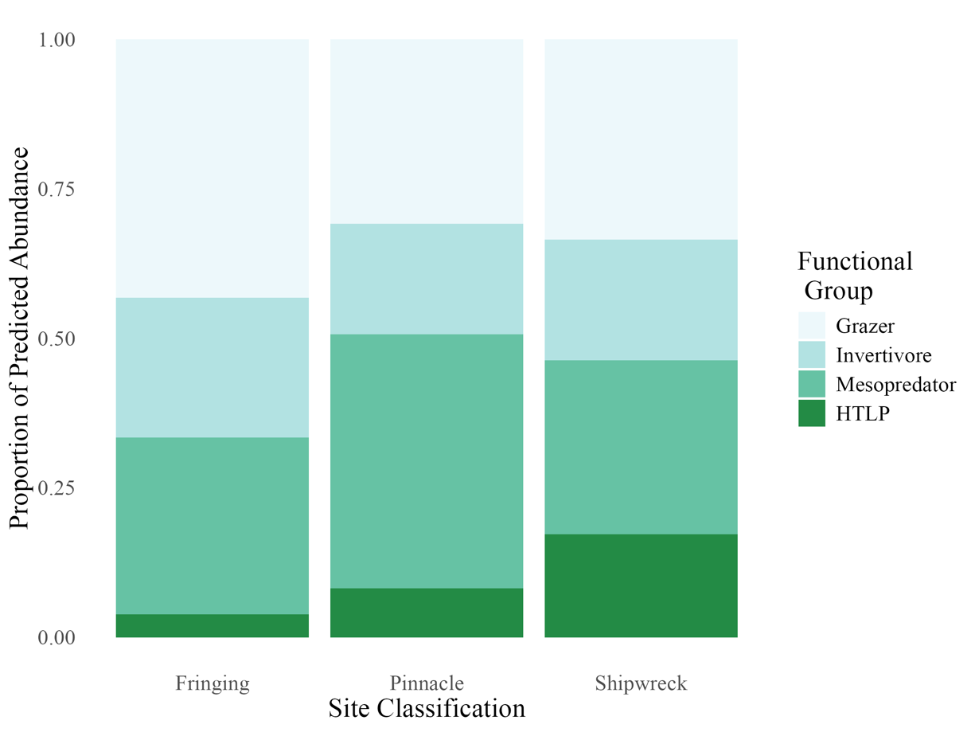
Figure 2 Predicted mean abundances of four functional fish groups—grazers, invertivores, mesopredators, and higher trophic level predators (HTLPs)—across three reef classifications: fringing reefs, pelagic pinnacles, and shipwrecks. Each panel displays the posterior mean abundance for one functional group based on multivariate negative binomial models.
ALT TEXT Figure 2: Stacked bar chart showing the proportional predicted abundance of four fish functional groups across three reef site types: fringing reefs, pinnacles, and shipwrecks. Each bar is divided into four horizontal segments representing grazers at the top, followed by invertivores, mesopredators, and higher trophic level predators at the bottom. Grazers occupy the largest proportion in all site types, while higher trophic level predators form the smallest but slightly higher proportion on shipwrecks compared to reefs. The predicted proportions of each group are visually very similar for pinnacles and shipwrecks. Colours range from pale to dark green, indicating increasing trophic level. The chart highlights differences in functional composition among reef environments.
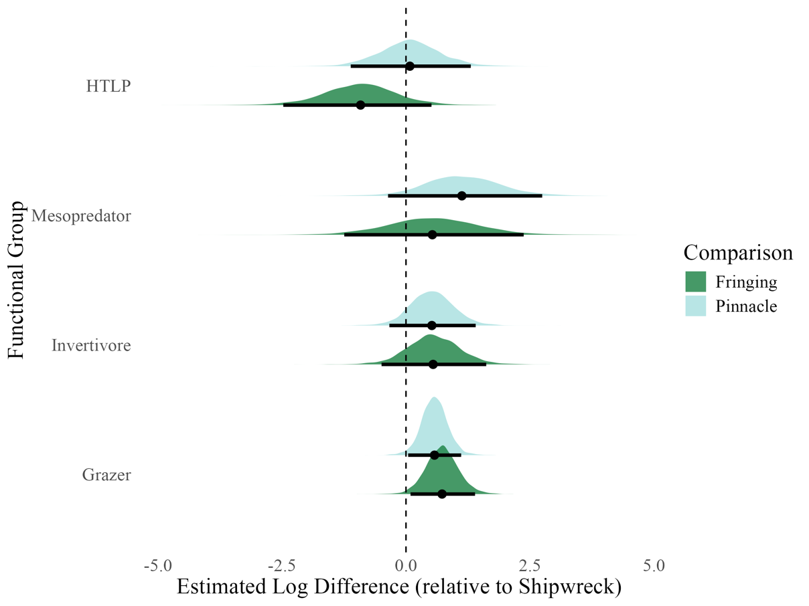
Figure 3 Posterior distributions show estimated log-scale differences in abundance for each functional group on fringing reefs (dark green) and pinnacles (light blue), relative to shipwrecks. Densities represent posterior uncertainty, with medians (dots) and 95% credible intervals (thick bars) overlaid. Zero indicates no difference from shipwrecks; positive values denote higher predicted abundance.
ALT TEXT Figure 3 : Ridgeline plot showing posterior distributions of estimated log differences in fish abundance for four functional groups—grazers, invertivores, mesopredators, and higher trophic level predators—on fringing reefs and pinnacles relative to shipwrecks. Each group has two mirrored distributions: dark green for fringing reefs and light blue for pinnacles. Dots mark medians and thick bars show ninety-five percent credible intervals. Grazers and invertivores show consistently higher abundances on both natural reef types compared to shipwrecks. Mesopredators show moderate overlap around zero, indicating little difference among reef types. Higher trophic level predators on pinnacles are nearly identical to shipwrecks, while those on fringing reefs are notably lower. The dashed vertical line marks no difference from shipwrecks.
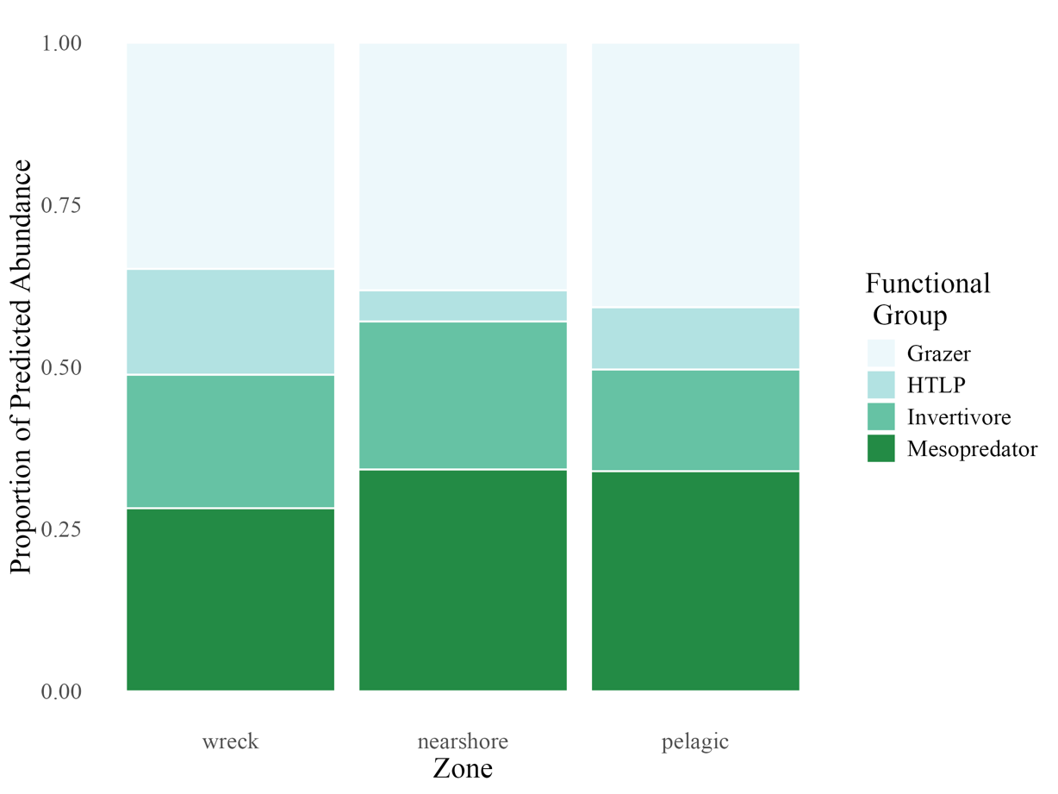
Figure 4 Predicted proportional composition of four functional fish groups across three reef zones (defined by proximity to shore): wreck, nearshore, and pelagic. Each bar represents the relative contribution of grazers, invertivores, mesopredators, and higher trophic level predators (HTLPs) to the total fish count within each zone. Proportions are normalised to 1.0 for comparison across zones.
ALT TEXT Figure 4: Stacked bar chart showing the proportional predicted abundance of four fish functional groups—grazers, invertivores, mesopredators, and higher trophic level predators—across three reef zones: wreck, nearshore, and pelagic. Each bar is divided into four horizontal layers, from bottom to top: mesopredators, invertivores, higher trophic level predators, and grazers. The relative proportions are similar across zones, but mesopredators form a slightly larger share in nearshore and pelagic sites compared to wrecks, while higher trophic level predators contribute slightly less offshore. Grazers consistently dominate the upper portion of all bars, indicating stable representation across zones.
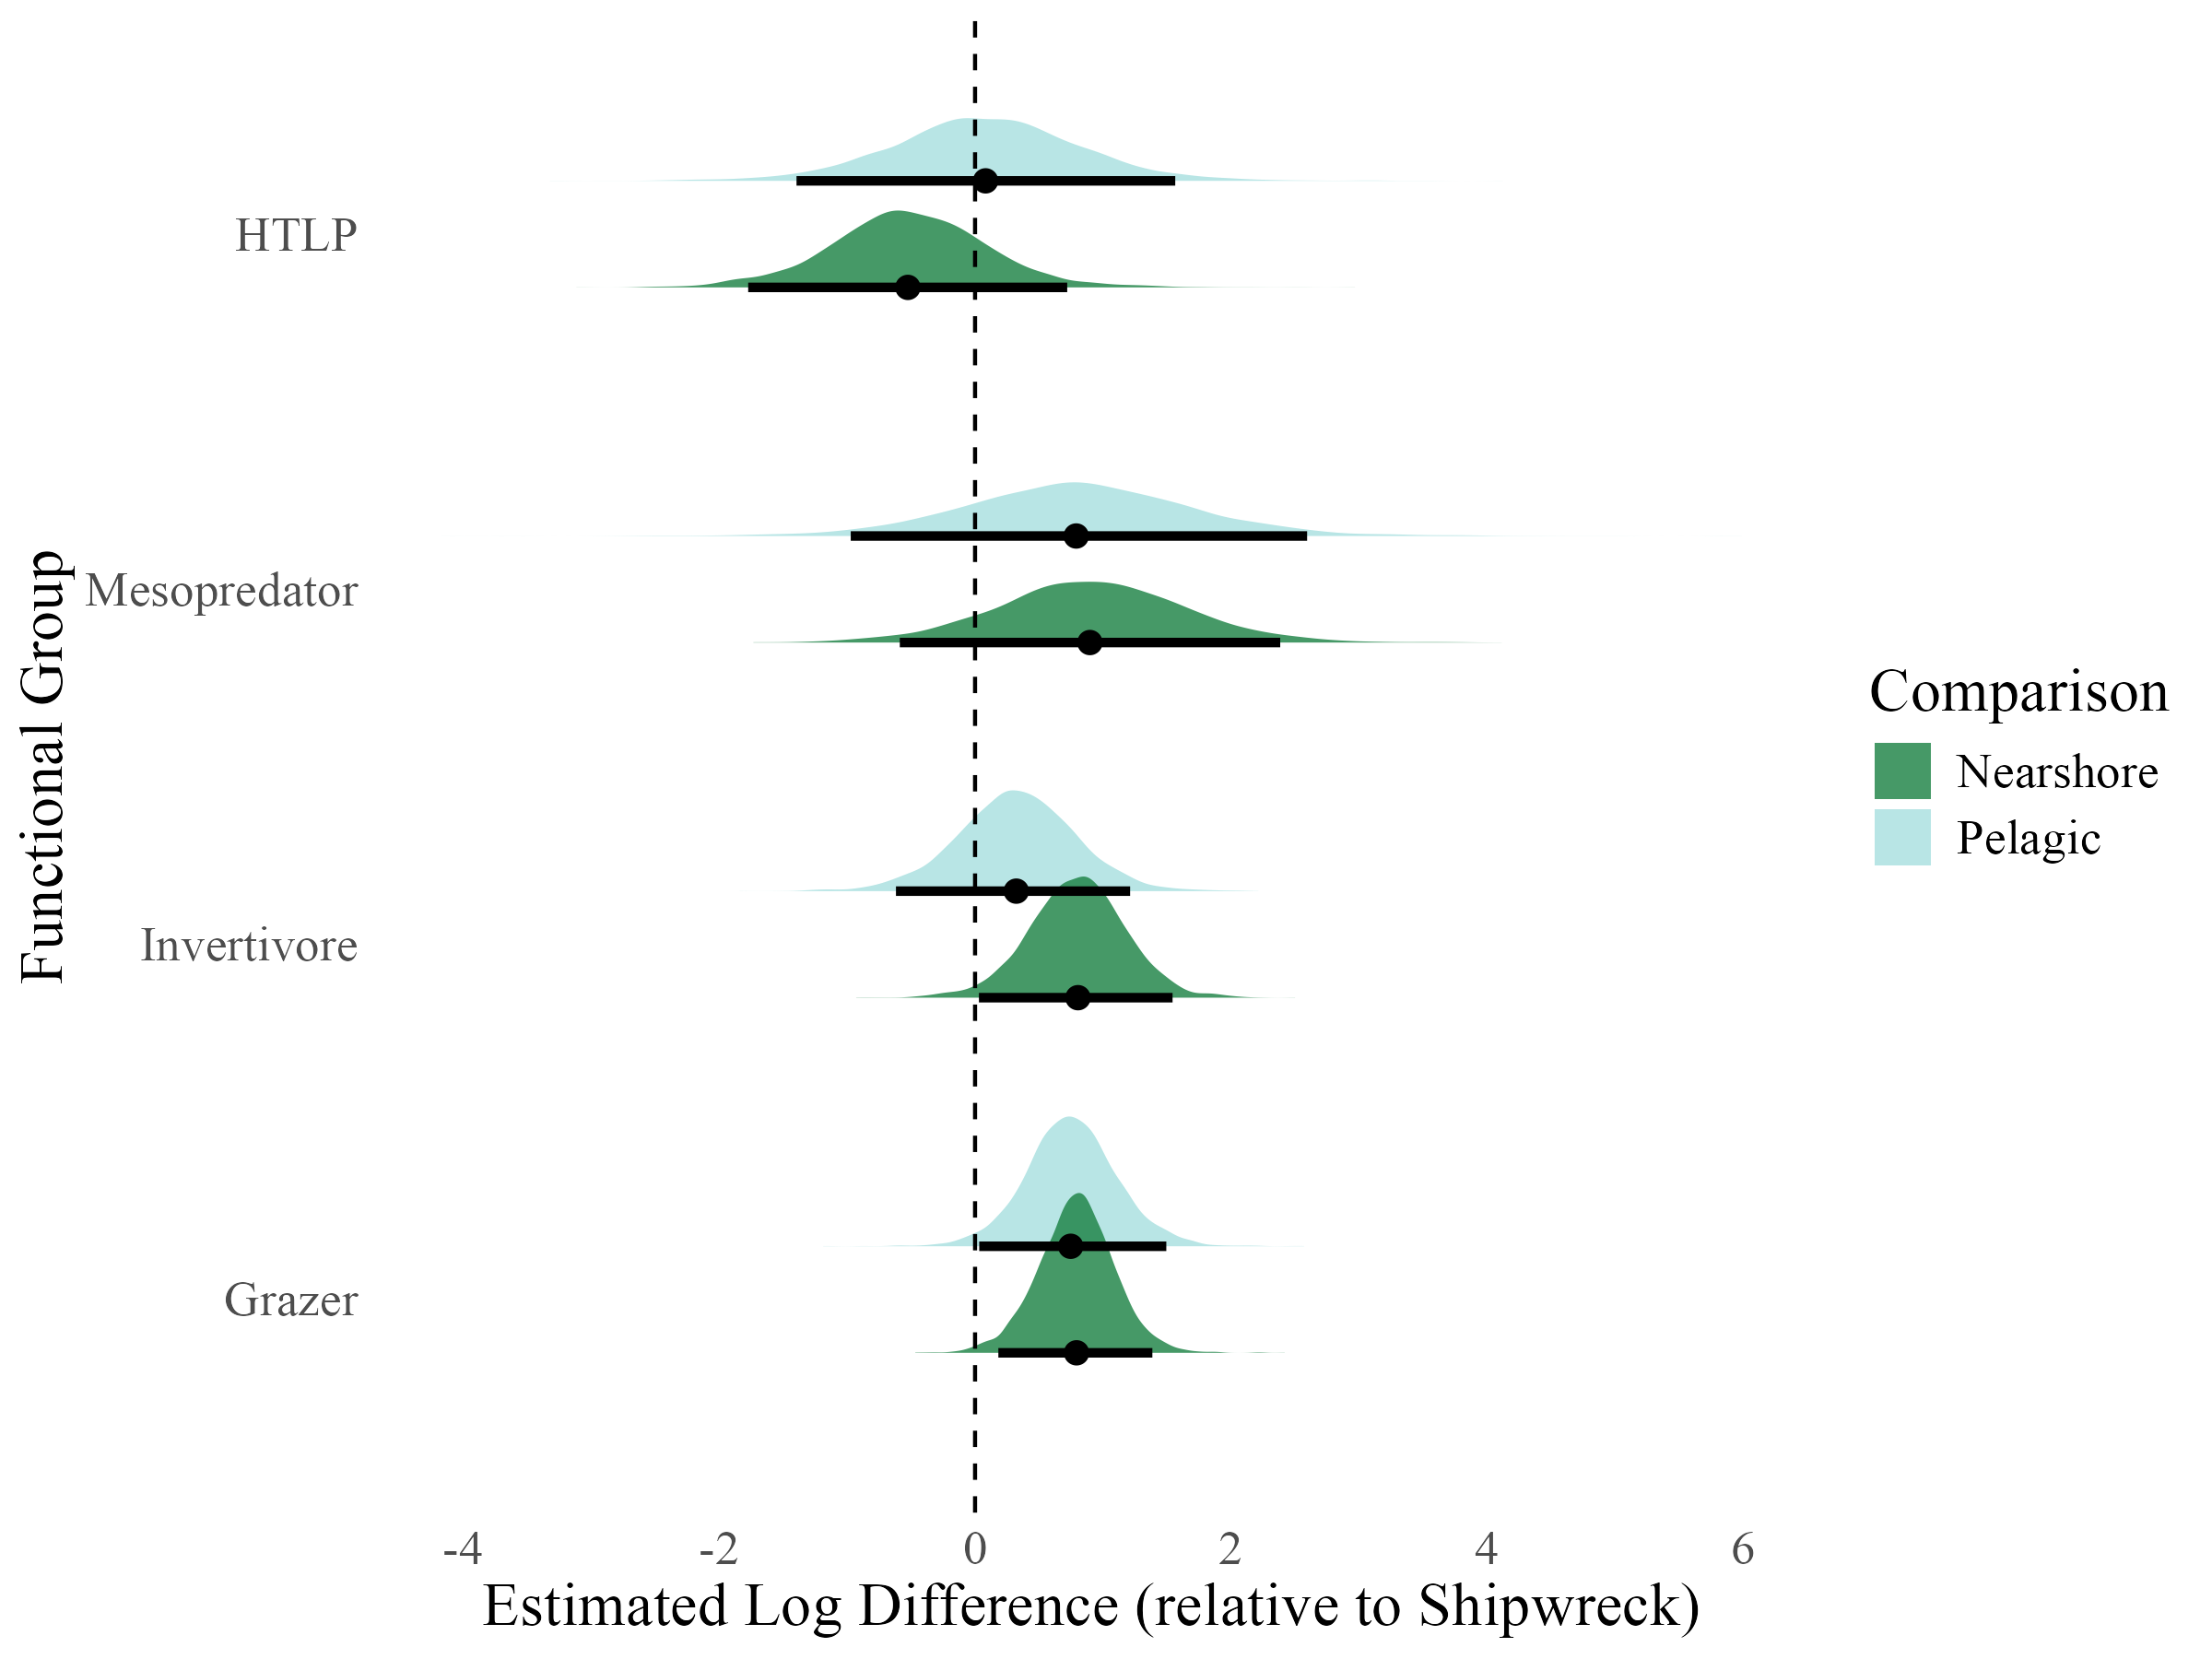
Figure 5 Posterior distributions show estimated log-scale differences in abundance for each functional group in nearshore (dark green) and pelagic (light blue) zones, relative to shipwrecks. Densities represent posterior uncertainty, with medians (dots) and 95% credible intervals (thick bars) overlaid. Zero indicates no difference from shipwrecks; positive values denote higher predicted abundance.

ALT TEXT Figure 5: Ridgeline plot showing posterior distributions of log-scale abundance differences for four fish functional groups—grazers, invertivores, mesopredators, and higher trophic level predators—on nearshore and pelagic reefs relative to shipwrecks. Each group has two overlapping distributions: dark green for nearshore and light blue for pelagic. Dots mark medians, and thick bars show ninety-five percent credible intervals. Grazers, invertivores and mesopredators display positive values in both zones, indicating higher abundance than shipwrecks, with slightly stronger effects offshore. Higher trophic level predators are marginally lower in nearshore sites but near zero in offshore zones. The dashed vertical line represents no difference from shipwrecks.
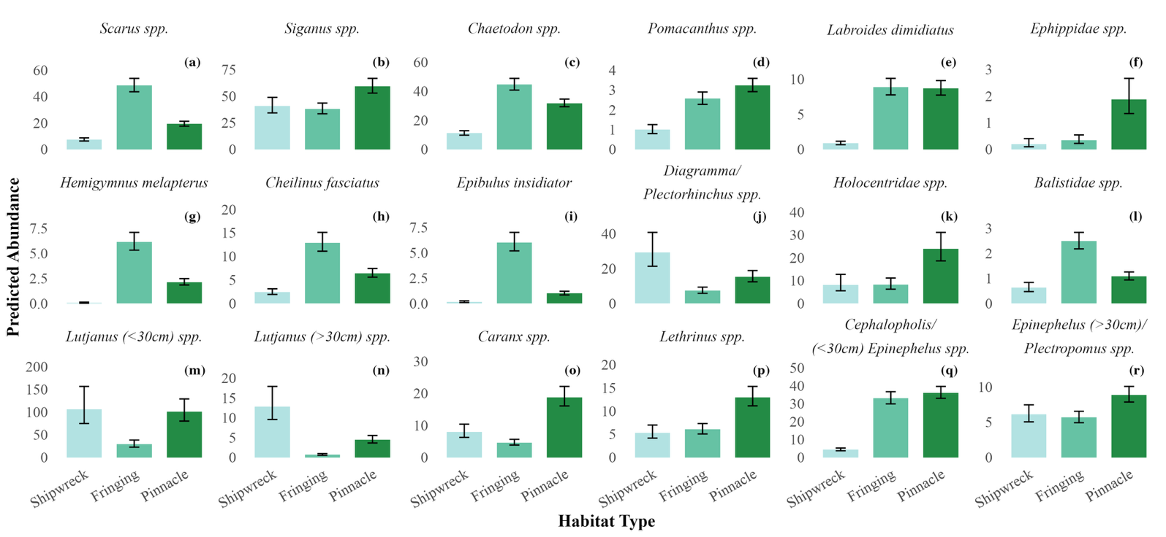
Figure 6 Predicted mean abundances of 18 reef fish taxa (a through r) across three reef classifications: fringing reef, pinnacle, and shipwreck. Each panel represents one species, with bars showing the posterior mean abundance from multivariate negative binomial models. Error bars represent Bayesian 95% credible intervals. Bars are coloured by reef classification to facilitate comparison of relative abundance patterns across reef types.
ALT TEXT Figure 6: Grouped bar chart showing predicted mean abundances of eighteen reef fish taxa across shipwreck, fringing reef, and pinnacle habitats. Most species show higher predicted abundance on pinnacles and fringing reefs compared to shipwrecks. Grazers such as Scarus and Siganus species are most abundant on pinnacles, while invertivores like Chaetodon, Pomacanthus, and Labroides also peak on natural reefs. Predatory taxa including Lutjanus, Caranx, and Lethrinus show elevated abundance on pinnacles, with shipwrecks supporting smaller populations. Smaller-bodied species such as Cephalopholis under thirty centimetres show minimal presence on wrecks, while large-bodied predators like Epinephelusare similar across reef types. Overall, pinnacles consistently support the highest fish abundance across functional and trophic groups.
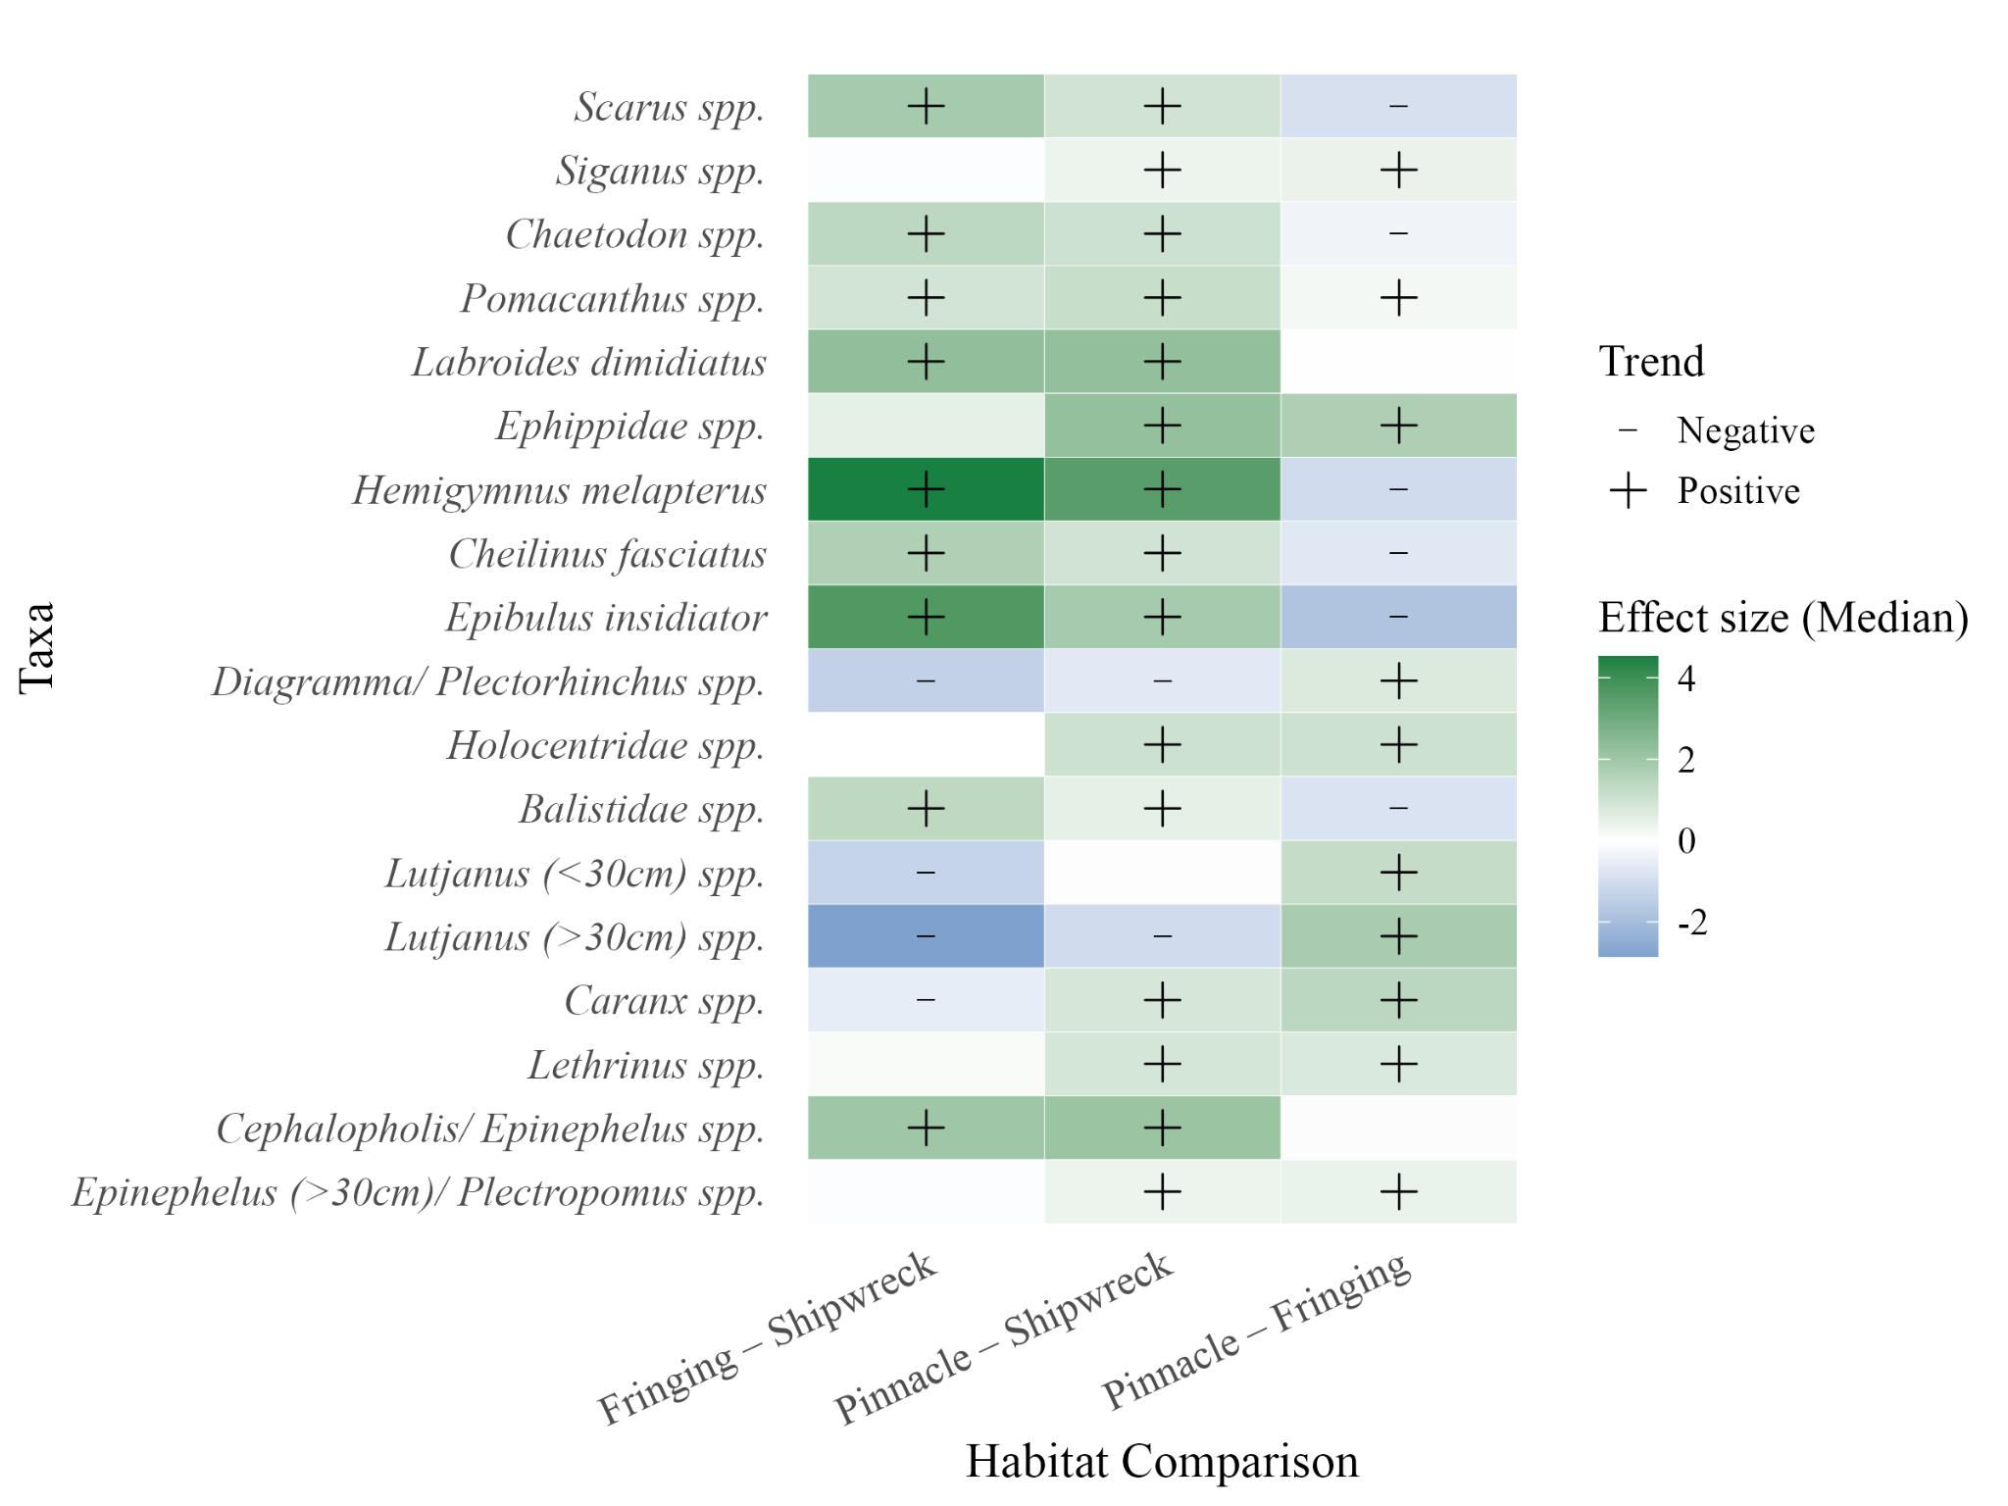Figure 7 Species-level estimates of fish abundance differences across habitat types, relative to shipwrecks, from a Bayesian multivariate model. Each tile represents the median posterior effect size for a given species–habitat comparison (Fringing or Pinnacle reef vs. Shipwreck baseline). Positive values indicate higher predicted abundance on natural reefs relative to shipwrecks, and negative values indicate the opposite. Black symbols denote species with strong support for directional effects (posterior probability > 0.95 or < 0.05); plus signs indicate positive effects, and minus signs indicate negative effects.
ALT TEXT Figure 7: Heatmap showing species-level differences in fish abundance among habitat types. Each row represents a reef fish taxon, and columns compare fringing and pinnacle reefs against shipwrecks, and pinnacles against fringing reefs. Most taxa show positive effects for both natural reef types relative to shipwrecks, especially Hemigymnus melapterus, Cheilinus fasciatus, Pomacanthus, and Labroides dimidiatus. Grazers like Scarus and Siganus are also consistently higher on reefs. A few taxa, such as Lutjanus and Caranx, show negative or uncertain differences, indicating greater abundance on shipwrecks. Comparisons between pinnacles and fringing reefs are generally weak, though some predators show slightly higher abundance on pinnacles. Overall, most reef species exhibit higher predicted abundance on natural reefs than on shipwreck.

ALT TEXT FOR EQUATIONS

Equation 1 – L201:
“The model specified the joint response as:
$$mvbind\left(Grazer, Invertivore, Mesopredator, HTLP\right) \\ \sim Classification +\left(1 \right| Month_Year) + (1 +| Site)$$
allowing inference across groups while accounting for potential correlations in abundance patterns.”
Alt Text – Equation 1 (Functional group model structure)
Equation showing a Bayesian multivariate model where fish abundances for four functional groups—grazers, invertivores, mesopredators, and higher trophic level predators—are modelled jointly. The response combines all groups with “mvbind,” predicted by reef classification and random effects for month-year and site. Random terms account for temporal and spatial correlation. Shipwrecks are the reference level. This formulation allows shared inference across groups while estimating distinct effects for each.

Equation 2 – L230:
“The response for each group $g$, at site $i$, survey $j$, was modelled as:
$$Y_{ijg }\sim NegBinom ( μ_{ijg}, ϕ_{g})$$
$$log(μ_{ijg}) = α_{g} + β_{g1} * Fringing_{j }+β_{g2} * Pinnacle_{j} + μ_{ig} +v_{mg}$$
$μ_{ig }\sim N (0, {σ^{2}}_{site,g})$, ${ v}_{mg }\sim N (0, {σ^{2}}_{month_year,g})$
Here, $Y_{ijg }$ represents the count of fish in group $g$ at survey $j$ within site $i$, $μ_{ijg}$​ is the expected count, $ϕ_{g}$ is the dispersion parameter, $μ_{ig }$​ is the random site effect, and $v_{mg}$ is the random month-year effect..”
Alt Text – Equation 2 (Group-level negative binomial model)
Equation showing the likelihood and linear predictor for the multivariate negative binomial model. The expected fish count for group g at site i and survey j follows a negative binomial distribution with mean mu and dispersion parameter phi. The log of mu equals the group intercept plus fixed effects for fringing and pinnacle reefs and random effects for site and month-year. Random effects are normally distributed with group-specific variances. Positive coefficients indicate higher abundance than on shipwrecks, the reference.

Equation 3- L259:
“The response structure and model family remained identical to the classification-based model, with the predictor variable replaced by zone (nearshore, pelagic, or shipwreck):
$$mvbind\left(Grazer, Invertivore, Mesopredator, HTLP\right) \\ \sim Zone+ (1 +| Month_Year) + (1 +| Site) \\ Y_{ijg }\sim NegBinom ( μ_{ijg}, ϕ_{g})$$
$$log\left(μ_{ijg}\right)= α_{g} + β_{g1} * Nearshore_{j}+β_{g2} * Pelagic_{j} + μ_{ig}+v_{mg}$$
$$μ_{ig }\sim N \left(0, {σ^{2}}_{site, g}\right){, v}_{ig }\sim N (0, {σ^{2}}_{month_year,g})$$

Where $Y_{ijg }$ represents the count of fish in group $g$ at survey $j$ within site $i$, $μ_{ijg}$​ is the expected count, $ϕ_{g}$ is the dispersion parameter, $μ_{ig }$​ is the random site effect, and $v_{mg}$ is the random month-year effect. Shipwrecks were retained as the reference level for interpretability.”
Alt Text – Equation 3 (Zone-based model structure)
Equation showing a multivariate negative binomial model with the same hierarchical structure as the classification model but replacing reef type with geographic zone—nearshore, pelagic, or shipwreck. The log of expected abundance equals an intercept plus fixed effects for nearshore and pelagic zones, and random effects for site and month-year. Shipwrecks again serve as the reference level.

Equation 4- L286:
“The response was specified as a multivariate bind of all included species, enabling joint estimation while accounting for overdispersion structured as:
$$mvbind(Species_{1}, Species_{2}, ... , Species_{n}) \sim Classification$$
The response for species $s$at survey $j$ was modelled as:
$$Y_{js }\sim NegBinom ( μ_{js}, ϕ_{s})$$
$$log(μ_{js}) = α_{s} + β_{s1} * Fringing_{j }+β_{s2} * Pinnacle_{j}$$
Here, $Y_{js }$​ represents the count of species$s$ in survey $j$, $μ_{js}$​ is the expected count, $ϕ_{s}$​ is the species-specific dispersion parameter, and shipwrecks were treated as the reference category. Site and month-year were not included as a random effect due to limited data and resulting model instability.”
Alt Text – Equation 4 (Species-specific model)
Equation showing a multivariate negative binomial model for multiple reef fish species. The response binds all included species jointly and models each as a function of reef classification. The expected abundance for each species equals an intercept plus fixed effects for fringing and pinnacle reefs relative to shipwrecks. Site and month-year random effects are omitted to improve convergence. This model estimates habitat-specific abundance differences at the species level.

